2. Show a picture of your final QPSK transmitter. Explain briefly what the different blocks are for. Explain how you checked that it was working correctly. A plot of the output showing important signals would be very helpful.

The picture of our QPSK transmitter is as follows:

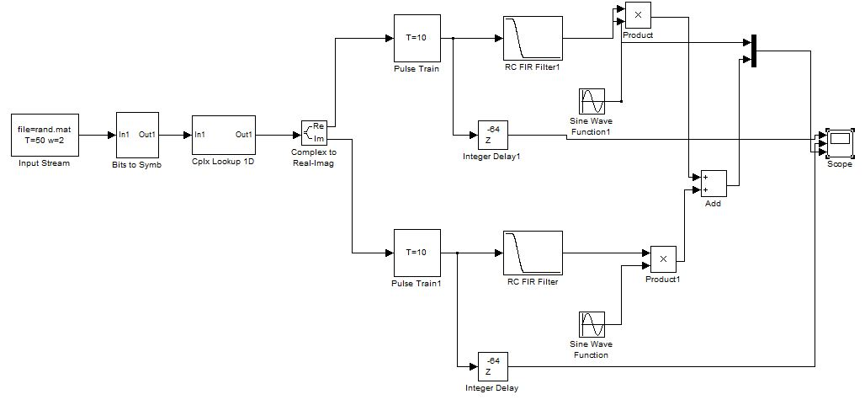

The different blocks used and their uses are as follows:

* Input Stream: reads a file named ‘rand.mat’ which has a stream of 1’s and 0’s. The bit period is 50 samples and output width is 2.
* Bits to Symbols: maps the bits to constellation diagrams. It takes a vector of N bits and maps them to the indices 0 to 2N-1 with the least significant bit appearing first.
* Cplx Lookup 1D: plots the complex symbols to the real and imaginary axis as [1 j -1 -j]
* Complex to Real-Imag: splits the complex values into real and imaginary parts which are then treated separately.
* Pulse train: generates a pulse train at the symbol period on both real and imaginary part of the transmitter.
* RC FIR Filter: used for pulse shaping. Low pass filter filters the high frequency components (edges).
* Integer Delay: adds some delay to the pulse trains so that the comparison of the pulse train with the modulated signals becomes easier. Here we delay the pulse train by 64 samples.
* Sine wave function: does the up-conversion. Here, we multiplied the real part of the signal by a cos and the imaginary part by –sin(by adding a phase of pi/2).
* Product: outputs the product of the message signal and the carrier signal.
* Add: adds the real and imaginary parts after up-conversion
* Multiplexer: combines multiple input signals into a vector. Used for signal routing
* Scope: displays the waveforms of the various outputs

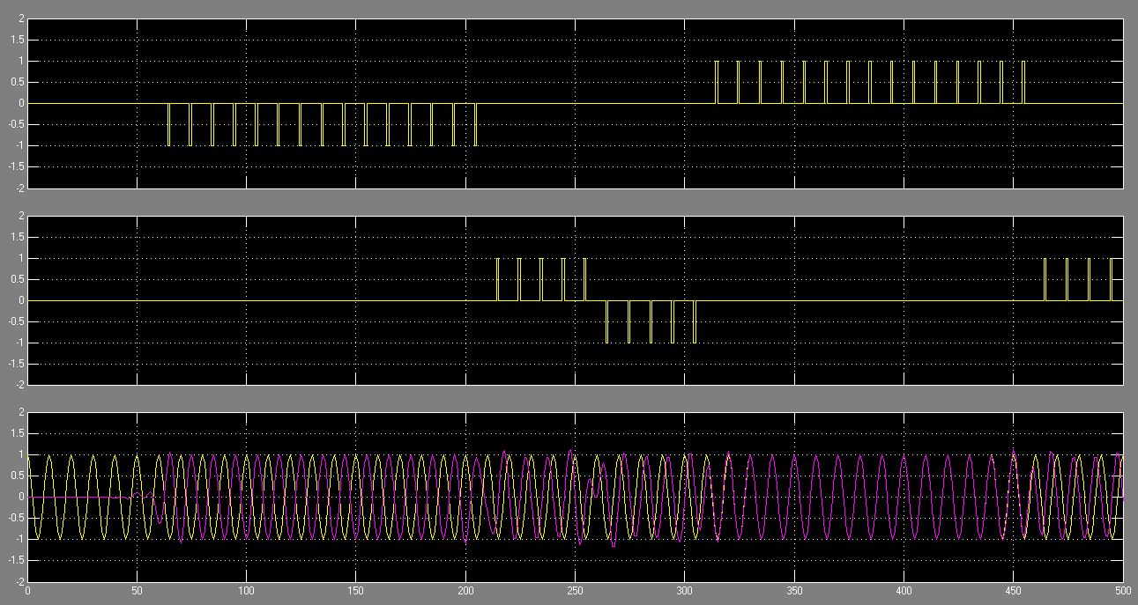

Fig: (from top to bottom) real part of the pulse train, imaginary part of the pulse train and modulated and added signal ready for transmission

We checked that the circuit was working correctly by comparing the modulated signal with the original delayed signal. As seen above in the plot, though it may not seem clear here, when the signal goes to 1 the modulated and carrier signals are in phase but when the signal goes to -1, they are out of phase.

Also, looking at the imaginary part, when it goes to 1 from -1, our modulated and carrier signal goes from leading position to lagging position. Hence, we concluded that the circuit was working fine.